**Database and file Management Systems** (CIS 2109)

**Lab 1**

**(1) Reference Chapters 1 and 4 in "Modern Database Management"**

a. Open Oracle SQL Developer and connect to the database following the instructions in the file Connection_Instructions.doc

b. Download from canvas the file: Lab_01_scripts.sql and open it in Oracle SQL Developer using:

File -> Open and browse to locate the Lab_01_scripts.sql file

c. Execute ALL the commands in this file by clicking on the button shown in the figure:

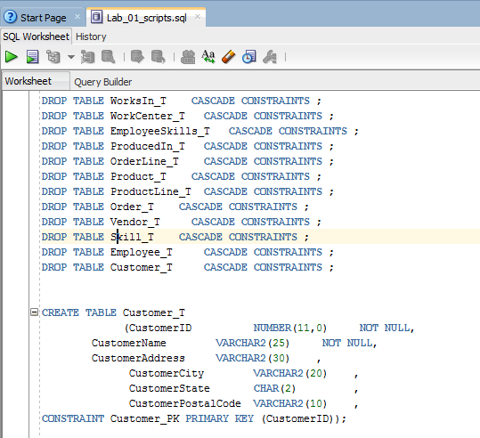

d. Now you have tables and data in your database!

e. Take a look at the data and answer the following questions:

1. What is the datatype of CustomerAddress?
2. Is the attribute CustomerName allowed to be NULL? What about CustomerAddress?
3. Who is the customer with CustomerID = 1 ?
4. How many orders has this customer placed?
5. Which Products has this customer purchased?
6. Now answer the same questions for the customer with CustomerID = 7.

f. Now take a look at the various tabs that are available for every table, and answer the following questions:



1. How many and what type of constraints do you see in table CUSTOMER_T?
2. How many and what type of constraints do you see in table ORDER_T?
3. If you wanted to insert the following record in table ORDER_T, should you be able to? Will you able to do it?

|  |  |  |
| --- | --- | --- |
| ORDERID | CUSTOMERID | ORDERDATE |
| 1011 | 20 | 20-NOV-11 |

**Deliverables:** Upload on canvas 1 word document that contains your comments and screenshots of your work.